**REACT TRAINING REPORT**

**A SUMMER TRAINING REPORT**

*Submitted by*

**Harsh Manoor**

**19BCS3531**

*in partial fulfilment of summer training for the award of the degree*

*of*

BACHELOR OF ENGINEERING

IN

COMPUTER SCIENCE AND ENGINEERING



APEX INSTITUTE OF TECHNOLOGY

CHANDIGARH UNIVERSITY, GHARUAN

District, State

OCTOBER,2021

**APPENDIX-II**

**CONTENTS**

Title Page i

Certificate ii

Acknowledgement iii

List of Figures iv

List of Tables v

List of Photographs vi

ABSTRACT …

CONTENTS …

CHAPTER 1 INTRODUCTION 1 1.1 About React …

1.2 Requirement …

CHAPTER 2 THEORY

2.1 Introduction …

2.2 Tic Tac Toe

2.3 Box Office

2.4 Chat Application …

CHAPTER 3 PROBLEM FORMULATION

3.1 Section

CHAPTER 4 METHODOLOGY ADOPTED

4.1 Section …

CHAPTER 5 RESULTS AND DISCUSSIONS

5.1 Section …

5.2 Section …

CHAPTER 6 CONCLUSIONS AND FUTURE SCOPE OF STUDY

REFERENCES

Appendix

**ABOUT THE COMPANY–**

We are a technology company on a mission to equip students with relevant skills & practical exposure to help them get the best possible start to their careers. Imagine a world full of freedom and possibilities. A world where you can discover your passion and turn it into your career. A world where you graduate fully assured, confident, and prepared to stake a claim on your place in the world.

**CERTIFICATE –**

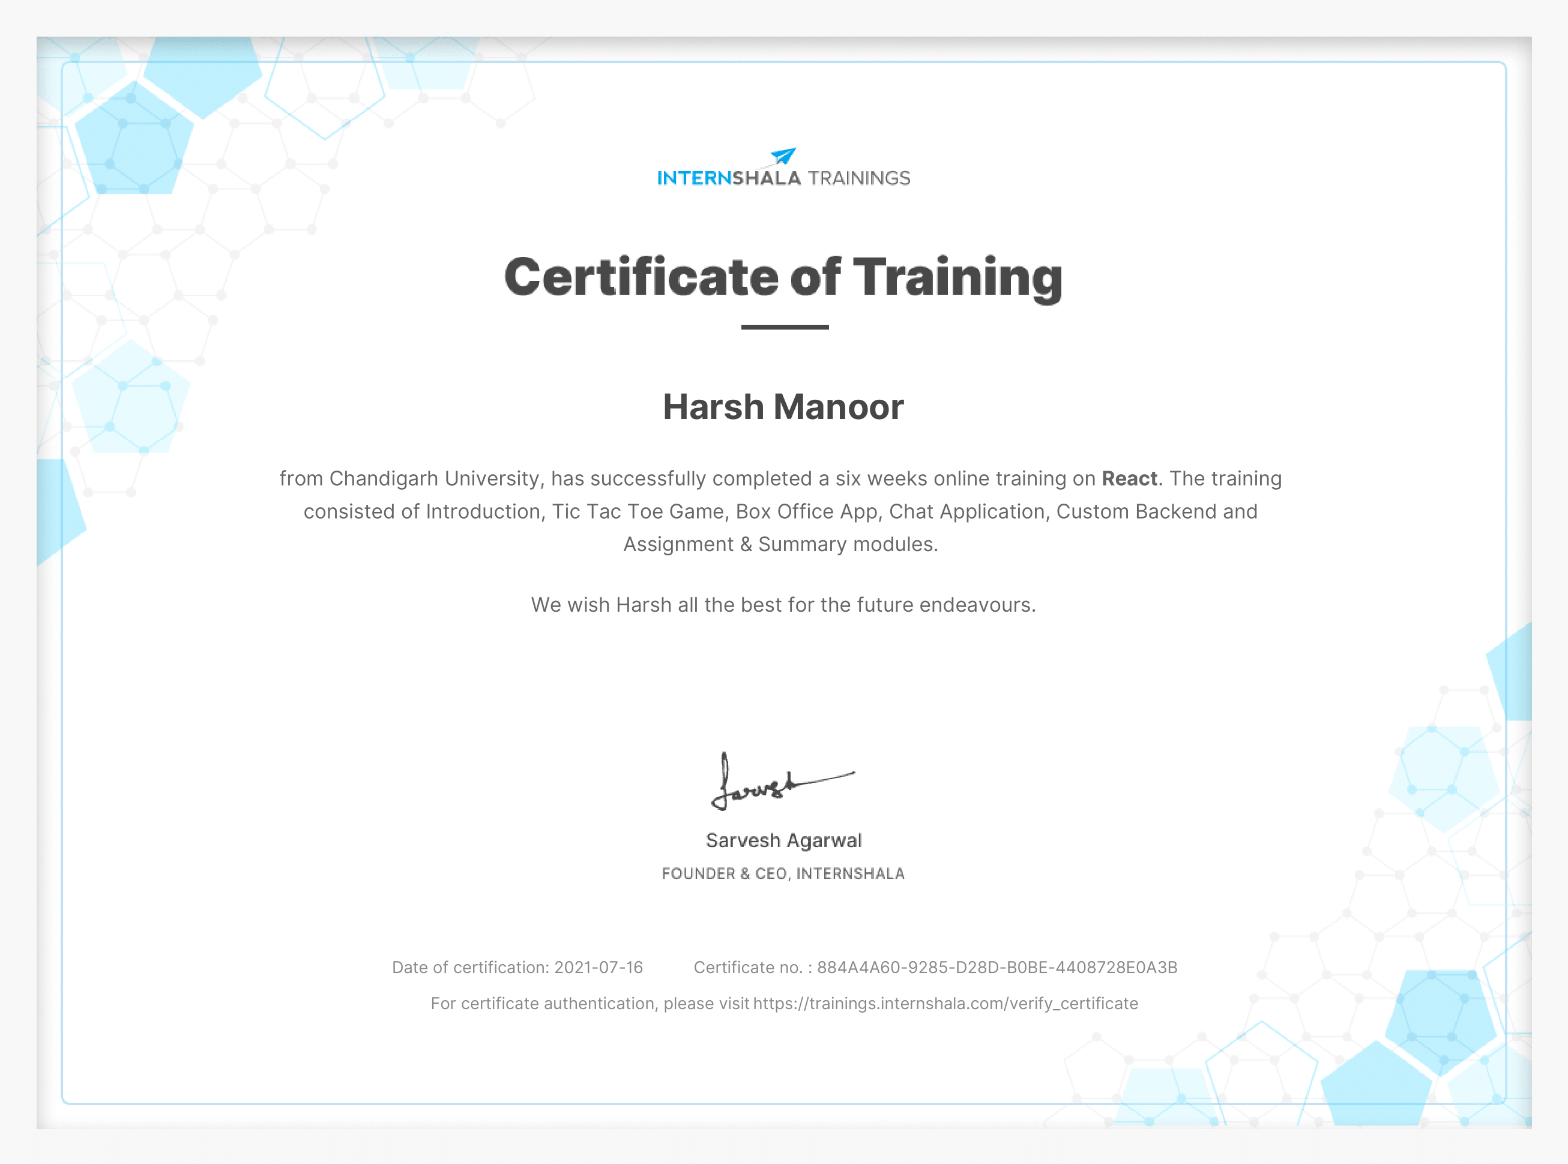

**ACKNOWLEDGEMENT –-**

It has been an honor to work under my guide, Andrii Hulenko (React developer) with many years of programming experience. I am extremely thankful to him for his support and mentorship throughout the training. I also extend a heartfelt gratitude towards my co-guide, Arash Ahadzadeh, 10+ years of experience as a UI designer, graphic designer, and application developer. Teaches UI design at University of Economics & Human Sciences, Poland. This project would not have had better supervisors than them. It adds to my pleasure to acknowledge The whole team of internshala , who have helped me while the project work was in progress. Lastly, I would like to thank my family and friends for their kind support. I feel grateful to Lord Almighty who has showered His graces upon me during this period.

**ABSRACT–**

This industrial training report of React training to undergo an industrial training for duration of 4 month which consist of 16 weeks before completing the Btech courses. Starting industrial training on 8 Jun'21 until 20 Jul'21 at Internshala which guided by Andrii Hulenko and Arash Ahadzadeh. The purpose of this program is to fulfil the course in order to complete the summer training as well as graduate from the college. The training refers to work experience that is relevant to professional development prior to graduate. In first chapter this report is defining the term of industrial training and description on industrial training objectives. This part explains the details of objectives of industrial training report and industrial report. In second chapter of report consists of theory of all modules and concepts learnt during the industrial training. The next chapters describe the problem formulation, methodologies and activities that carried out. This training gives students a good experience in ReactJs. Last but not least, trainee got opportunities to learn more about website development with latest technologies ReactJs.

**PART-I**

**CHAPTER: 1 INTRODUCTION**

In the Internshala Training we are going to cover React. It’s an open-source front-end JavaScript library for building user interfaces or UI components. It is maintained by Facebook and a community of individual developers and companies. React can be used as a base in the development of single-page or mobile applications. If you want to make an application like twitter and Facebook, we are going to cover all these topics. In this we made three projects of different complexity – Tic Tac Toe game, Movie Search app and a chat application.

ReactJS has become highly popular because of its extra simplicity and flexibility. Many people are even referring to it as the future of web development. It is estimated that more than 1,300 developers and over 94,000 sites utilize ReactJS. In first module we covered NodeJS, Git, server-side rendering and API. We also cover Styling of web pages, dynamic routes, remote data fetching using API and optimize and analyse react components. At the end of each module there is a quiz test. After giving each quiz next module will be unlocked. After completing all the module there is final test and individual should get more than 30% to get eligible for certification.

Requirements: To start working with React we have knowledge about HTML and CSS (No need to get advanced) and have some basic general programming knowledge.

**CHAPTER: 2 THEORIES**

**Module 1: Introduction**

In first module we going to install essential tools to start with the react. To write any code we need an Integrated Development Environment. In this we are using Visual Studio Code to make react applications. To manage our project, we need a version control system to handle everything from small to large project. In git we cover all the commands like git status, commit, and push. After installing all essentials for project, we are going to cover Client and Serve side rendering. We also going to cover what is Server, JSON, GraphQl and REST API.

After this we going to talk and discuss about Modern JavaScript and essential features that we should know before we jump into programming. In JavaScript section we covered:

* Let vs Var vs Const
* Array. Map and Array. Reducer methods
* Function declaration
* String Interpolation
* Object and Array Destruction
* Spread Operator
* Async and Sync code

**Module 2: Tic Tac Toe**

After introduction, now it’s time to get dive into project stuff. Our first project using React is Tic Tac Toe. In this we made us react first project and installing some dev dependencies like Eslint and Prettier – which is a code formatter. We started our project by starting with making a component. After this children props came into the picture, how they pass different data to different components. After scaffolding the project, we calculate winner and to calculate JavaScript is used. We also added game history feature which can roll back the move. Completing all this, last step is to highlight the winner state. After completing project, we deploy it on surge.sh – which is a free hosting platform to host react application. These tic-tac-toe panels improve hand-eye coordination and encourage better social interaction by better collaborative play. And children shouldn't just play with other children. Parents also have a role in the playground more than being supervisors.

**Module 3: Box Office App**

In first project we learned basics of the react application, creates components and host our first react application. In this project we made an application named as “Box Office”. It will display the data of all TV movies, shows and it will also display about the actors. In home page we have search bar, if we look for any shows and actors just type name and press search and it will give list of all shows and actors. For fetching data, we use API of “api.tvmaze.com”. To get API we use multiple functions and events to input data and rendering all the results. They eliminate the long minutes you have to wait. You will find them very easy to use and can save you money and time. Since they are installed on a smartphone or tablet, which are devices that can be carried around, you are free to find favourite movies from across the world. For this react app, we are going to deploy application on github-pages. GitHub Pages is a static site hosting service that takes HTML, CSS, and JavaScript files straight from a repository on GitHub, optionally runs the files through a build process, and publishes a website.

**Module 4: Chat Application**

Here we are at our final react project, which is Chat Application. In this we have a sign in page using google and Facebook then you are inside the app. In this we have options to create private chat rooms, dashboard, and list of chat rooms available. On the right you see all the chats. In dashboard we can manage our account like account association, nickname, and your avatar. After setting up account you can create a chat room, filling details like room title and description. By clicking on user name, you can see a modal window having username, user avatar, and admin permission. All message in chat application is split into date and grouped by dates.

In our case, it makes sense to give it three child components, which we’ll call the following:

* Title
* MessageList
* SendMessage from

The database we are using is Firebase. Firebase is a platform developed by Google for creating mobile and web applications. It was originally an independent company founded in 2011. In 2014, Google acquired the platform and it is now their flagship offering for app development.

Merits: One of the handy advantages of live chat is the option to see a real-time preview of what the customer is typing before she hits enter. It gives your chat agent the chance to think about a solution, research and impress users with prompt, customized answers, but what’s more is that the average resolution time is significantly lower than with traditional service channels.

**PART-II**

**CHAPTER 3: Problem Formulation**

The main problem solved by react is the development of large applications that have temporal data changes. The data in such applications is not static so it changes over time. We can look at React as the V layer in model-view-controller (MVC) pattern of software development. In the MVC pattern, you divide your application into three parts. The model implements the storage and retrieval of data in a database. The view is the part that displays the user interface while the controller receives user input and passes it to the model. React only enables the view part, so for model and controller parts you need to use other tools.

* It is simple. You just need to express the appearance of your app and react takes care of your user interface updates when there are changes in the data
* It is declarative. When changes in data happen React is aware of how to update the changes
* React is component based. This makes development of reusable code that is easy to test.

It solves this by giving the developer a virtual DOM to render to instead of the actual DOM, which it then diffs with the real DOM, and does the minimum number of DOM operations needed to achieve the new state.

This allows you (at least in theory) to completely forget about DOM performance, and you can simply re-render the entire page all the time, as soon as your state changes. This almost always results in much smaller and simpler code base, which leads to less bugs.

**CHAPTER 4: METHODOLOGY ADOPTED**

The various procedures and methods available that we used in our projects is using different hooks like useState, useRef, and useEffect. You have to take care of some things while developing an react application If the component name does not start with a capital letter, the component use will be treated as a built-in element such as a div or span. To solve problem/tasks for React users, react 16 introduces a new concept of an “error boundary”.

Error boundaries are React components that catch JavaScript errors anywhere in their child component tree, log those errors, and display a fallback UI instead of the component tree that crashed. Error boundaries catch errors during rendering, in lifecycle methods, and in constructors of the whole tree below them.

Various procedure/ methods available to solve the task/problem undertaken should be mentioned under this chapter.

After this, methodology adopted to solve the task to be explained followed by procedures, flow charts, calculations *etc* to be reported.

**CHAPTER 5: RESULTS AND DISCUSSIONS**

From the work carried out, the results obtained should be provided in the form of tables and figures under this chapter and each of these should have caption. Proper reasons and justification for the trends observed in the results should be provided under discussion on the results.

**CHAPTER 6 CONCLUSINS AND SCOPE FOR FUTURE STUDY**

From the work carried out and results obtained, specific conclusions should be drawn. Similarly, scope for the further work to be identified and placed under this heading.

**REFERENCES –**

The listing of references should be typed 4 spaces below the heading “REFERENCES” in proper order in single spacing left – justified. The reference material should have proper citation in the chapters in IEEE format.